**The Capital Project Planning Exercise**

**(Railway Sector)**

**Introduction**

Welcome on board! You have just been appointed a member of the inter-organizational group that has been formed to plan the redevelopment of the Salford Crescent Railway Station, a critically overcrowded interchange and pedestrian railway station in the UK’s North West region [**Exhibit 1**]. The station is owned by Network Rail (NR), a private company limited by public guarantee, and NR’s Enhancement division[1] has expressed interested in getting this project off the ground quickly.

As a member of this group, you are expected to contribute to a discussion of the pros and cons of a set of alternative designs that have surfaced after initial meetings with the most salient stakeholders as part of the so-called NR value management (VM) process. You have now to prepare for the final VM meeting, and thus read the summary of the alternatives below and extra information in a brief specific to your role. This VM meeting is important as the group wants to agree on the concept that will be part of a bid for funds from a grant that the national government has recently set up to encourage the modernization of old small and medium size railway stations.

If your bid is successful, the outcome of this meeting will therefore set a roadmap for project delivery, and critically, it will determine the operational performance of the Salford Crescent Railway Station over the next decades, which in turn will affect the development of the communities surrounding the station notably the university. Your group is expected to produce and agree a minute that spells out: 1. your recommendations for the design of the Salford Crescent railway station; 2. the rationale for your recommendations; and 3. any agreements reached for financing your plan. There is no such thing as a right or wrong set of recommendations and financial agreements, but your group wants to take seriously the need to justify your recommendations attending that this station gets dangerously overcrowded at peak time, and there is a credible threat it must close unless effective action is taken in the near future. All participants in the VM meeting will be accountable to varying degrees for the meeting outcome and thus for the future of the station in the decades to come.

**The Salford Crescent Railway Station**

Since the early 2000s, the relatively tiny Salford Crescent railway station, an interchange and pedestrian station constructed in 1983, cannot cope with the levels of patronage **[Exhibit 2]**. As a result, platform overcrowding has become a recurrent issue. Located at a key railway junction between services based on Manchester’s Piccadilly and Victoria Stations, Salford Crescent is a category C station[2]. It offers an easy cross platform interchange for passengers on trains to and from Manchester Piccadilly Station (via Manchester Oxford Road) to interchange with Victoria Station.

Built near the campus of the University of Salford, this station is highly used by students to the extent it is also signposted as "For University of Salford". The station is usually congested the whole day during the academic terms since student movement does not follow conventional commuter patterns. It also offers very limited facilities for passenger comfort. In the financial year 2007/08, the annual passenger usage of the Salford Crescent Railway Station was, based on ticket sales, 732,255 (including interchange). The overcrowding problem is compounded by the lack of space available for allowing passengers to circulate. The station consists of two platforms forming an island with a total width of 7m which can be accessed in the middle from a stepped ramp connected to a footbridge [**Exhibit 3**]. At the platform pinch-points (ramp, ticket office, waiting room), the space available for circulation is approximately just 2 metres. This is a key constraint to circulation to the extent that Northern Rail, the private train operator that also owns the franchise to operate the station needs to have in place various measures to mitigate the risk of an accident.

The Salford Crescent station has also problems to accommodate long trains. These are becoming increasingly attractive to Northern Rail as demand for services continues to increase steadily. At Salford Crescent, the platforms are 129 metres long, and therefore capable to accommodate 5-car trains of 24m-long cars. But this length is inadequate to accommodate Northern Rail’s preference for operating with more profitable 6-car trains of 24m-long cars. Furthermore, the 129m-long platform precludes NR from realising its aspiration to modify the track layout for enabling railway operations with at least 8-car trains throughout the North West region.

Salford Crescent fails to comply with the Disability Discrimination Act (DDA), which introduced stringent standards in 1995. The existing facilities basically consist of a canopy spanning part of the platforms, a waiting room, a ticket office, a Dispatcher’s office, and a stepped ramped access from the privately owned footbridge. But furniture on the platform cramps mobility. In addition, the access to the station for wheelchair users is inadequate, and the limited width of the platform in some areas disallows the use of ‘train ramps’ to help wheelchair users. Since the station was built before the publication of the Act, it can remain legally non-DDA compliant. But if the station is redeveloped, the minimum acceptable standards in the Act need to be met.

Importantly, the Salford Crescent redevelopment project is consistent with the long-term view of the UK government expressed in the white paper ‘Delivering a Sustainable Railway’ that was published by the Department for Transport (DfT) in July 2007. This document highlights a number of strategic plans to develop the rail network in order to contribute to the economic and environmental development of the country. Due to its capacity constraints, the Salford Crescent Station qualified for inclusion in the National Stations Improvement Programme (NSIP) – a government-sponsored programme providing £150 million of funding to support improvements at 150 category A-E rail stations across England and Wales. The programme aims ‘to bring about a noticeable and lasting improvement in the environment at stations for the benefit of passengers’. The government expects this capital investment to lead to an improvement of the chosen stations in terms of security, quality of access and egress, overall presentation, and information provision. NR as the landlord and the train operators as lessees are working together in this programme to help the rail industry meet the targets in terms of performance, capacity, reliability, and safety.

**The Salford Crescent Redevelopment Project**

The stakeholders relevant to the scheme are many. Whilst the station is property of NR, it is operated by Northern Rail, a profit-seeking company. Central Salford Urban Regeneration Company (URC) is another stakeholder as they are driving a £4bn capital programme to regenerate Salford in partnership with Salford City Council. Unsurprisingly, the local authority is also interested in this project from a planning and highway perspective. In addition, the University of Salford, which campus is located on both sides of the station, has an important interface because of its own plans to redevelop the campus. Finally, the Greater Manchester Passenger Transport Executive (GMPTE) is also interested in how the project affects its plans to build a new bus/rail interchange in the vicinity. Things have changed, however, from a financing perspective. Initially, DfT and GMPTE were both lined up as potential funders. GMPTE recently backed away, but NSIP funding remains available.

From a timescale perspective, planning started in December 2009 with a view to start construction in November 2012 and complete the station redevelopment project by the end of December 2014. To be successful, the project needs to: 1) meet the DfT high-level output specification (HLOS) metrics[3]; 2) minimise overcrowding on the railway network going through Salford Crescent; and 3) ideally meet the Council’s aspiration for direct Calder Valley services to and from Salford Crescent[4].

**The NR Value Management process**

The NR value management (VM) process is a methodology to assist project decision-making and ensure that all relevant stakeholders have a share of voice in the process. After a first meeting to discuss the project objectives and a second pre-feasibility meeting to map the objectives to an initial set of design alternatives, you need now to attend the third VM meeting and agree on the design concept to go in the bid for funding. Thus, you are expected to discuss the functional and operational requirements for the project, the extent to which the different alternatives address these requirements, and agree on the concept to move forward. NR’s team attending the meeting will include the project manager, chief engineer, and a commercial sponsor. Other people expected to attend the meeting include Northern Rail’s station manager, and executive members from Salford University and Central Salford URC. The salient issues around the main alternatives for redeveloping the Salford Crescent railway station that surfaced up to now are summarised as follows:

*(a) Abandon the project*

The costs of abandoning this project would be negligible since the stakeholders have only incurred marginal costs so far. NR would not be able to recover the costs already sunk in planning. Roughly, NR reckons it has incurred less than £200,000[5] up to this point. But if a collective decision is reached to abort the project, the operational costs for keeping passengers safe on the platforms are likely to escalate over time. In addition, there is a credible threat that the station would have to close.

*(b) Lengthen the island platforms*

This alternative would lengthen the island platforms to accommodate 6-car trains [**Exhibit 4**]. This would also enable short trains to stop at different locations on the platforms, which would attenuate but not eliminate the overcrowding problem since people would no longer need to conglomerate at the same place. Due to the lack of space, the island platforms cannot be lengthened to allow for operating 8-car trains. Operationally, this alternative would reduce interchange times although the modifications to the track layout which require altering switches and crossings[6] would need to be agreed with the operator. Since the construction works on site would affect two lines simultaneously, the negotiation of the line possessions[7] to carry on the works would not be trivial. Some stakeholders dislike this option because it fails to completely eliminate the overcrowding problem at the station platforms at peak time.

*(c) Add a third platform*

The addition of a longer third platform to Salford Crescent Railway Station would achieve the requirement to operate the station with the 6-car trains that Trans Pennine Express (TPE) uses at busy times without having to keep doors locked to prevent passengers getting out of them where there is no platform. This alternative could also be safeguarded to extend the new platform to accommodate 8-car operations at a reasonable cost in the future, or alternative the new platform could be built for receiving 8-car trains with some extra capital investment. In both cases, this alternative would build in operational flexibility. But it would not achieve revenue protection since passengers would have multiple access points to the station, making it more difficult to control ticketing. To achieve compliance with DDA, lifts for disabled passengers would need to be added both to the existing platforms and to the new one. Although the cost to build a new platform alone is relatively affordable ─ NR estimates it around £2.8m ─ the adaptation of the railway lines will likely be expensive as it will have to involve disruptive possessions. The number and duration of these possessions has not been quantified precisely at this stage, but negotiating possessions with the rail operators is always a difficult process. This alternative is also expected to increase significantly the operational costs for Northern Rail, although it also creates opportunity to run new services along the Calder Valley route, and thus business opportunities that Northern Rail could bid for in the future. There is also an inherent risk that a formal Station Change proposal is rejected by some stakeholders frustrated that this alternative does not account for delivering a new station building, neither for improving the conditions on the two existing platforms. In addition, the NR design team has indicated that the costs may escalate substantially to make the third platform operational since this requires significant interventions onto the lines.

*(d) De-clutter and extend existing island platforms, and move access to southern end*

NR estimates that implementing this alternative would cost around £7.5m (assuming a new landmark station building and no safeguards for a 3rd platform). Its scope consists of de-cluttering the island platforms (from existing buildings, access ramp, and furniture), extend the existing platforms, and adding a much longer canopy. To relieve overcrowding, a new station building would be built on NR land at the road level above, and a new walkway would be built connecting the new station building to the southern end of the platforms [**Exhibits 5 and 6**]. To comply with DDA, a lift for disabled passengers would need to be added. This scheme would make it easier for Northern Rail to manage the platforms as it would not create multiple access points to the station, thereby protecting the operating revenue of the firm. Based on preliminary pedestrian-flow studies, this alternative would make the station viable at a comfortable level until 2025. Discussions in the past indicate that Northern Rail is happy to endorse this proposal.

*(e) De-clutter the island platforms and move ticket office to east or west side*

The main advantage of this alternative is the cost, which NR estimates around £4.9m, because its execution would require minimal possessions. Whilst retaining the ramp to access to the platforms from the existing footbridge, this alternative would still relieve overcrowding and improve facilities. But it would fail to meet the projected passenger growth until 2025 since the space for circulation would remain problematic near the retained ramp in the middle of the platform. A drawback is the inadequacy of this alternative to protect operational revenue. As none of the entrances of the footbridge could be blocked due to right-of-way issues, passengers would have free access to the station from the east side (if the ticket office is located on the west side) or from the west side (if the office is located on the east side) **[Exhibit 7]**. This can put passengers off from buying tickets since those who access the bridge from the ‘free’ side would need to walk all the way to the other side to buy the ticket and come back to access the platform through the ramp. There are other risks associated with this alternative. First, to build the new ticket office, NR would to have to acquire land from the university which is not trivial. And second, there is a risk that Northern Rail fails to endorse this alternative if it dislikes the proposed layout changes. Critically, some stakeholders reckon it can be difficult to get the railway station building classified as a landmark building in the future if the existing ramp and footbridge are retained. This alternative would also complicate plans to add a third platform in the future.

*(f) Add a third platform, de-clutter and extend the island platforms, and move access to southern end of the island platforms*

NR estimates that the economies of scale to be achieved by combining alternatives (c) and (d) are limited, and therefore the cost of this alternative will be at least £10.3m. Of all alternatives, this is the one that resolves effectively the capacity bottleneck problems at the station, relieving overcrowding and significantly improving the facilities for decades to come. Based on the current projections for passenger growth, this alternative is expected to ‘future-proof’ the station up to circa 2045. This alternative does not eliminate nonetheless some of the disadvantages of the alternatives (c) and (d): (1) in the short-term, the operational costs for Northern Rail may increase due to the need to add more staff to control the new platform; and (2) the interchange times will also increase. In addition, the NR design team has indicated that the estimated cost may escalate substantially to make the third platform operational since this requires significant interventions onto the railway lines.

**Collective Task and Expected Deliverables**

By the end of your meeting, your group is expected to have agreed on the concept that will progress into delivery assuming your bid for funds is successful. Your recommendation needs consider a conflation of factors, including: 1) technical quality of the concept, 2) life-cycle costs[8], 3) interests of the different stakeholders, 4) financing and affordability issues, and 5) desirable project timescales. As you debate on the strengths and weaknesses of each alternative, bear in mind that each one has different implications both in terms of capital expenditure (CAPEX) and operational costs (OPEX). Your group needs to factor in its recommendation the pressing need to resolve the overcrowding problem as well as other needs that are foreseen to surface during the station’s operational lifetime. Lately, rumours have circulated of a new NR policy to bring in a so-called *Champion of* *Design for Evolvability* (?) to facilitate the discussions, but you are unclear of what the role entails and whether this will happen or not at all. For sure, the following people are expected to attend the meeting:

* **NR Project Manager**: in charge of completing the project plan and ensuring that the project unfolds in accordance to that plan. The project manager is expected to possess solid general knowledge about the project and of NR business more generally, relying on other people’s input for technical information.
* **NR Project Engineer**: responsible for ensuring that the design meets the standards, including construction design management (CDM) regulations, and enables to deliver the project to budget and within the planned timescale.
* **NR’s Commercial Sponsor:** works at the interface between NR and the private operators, being responsible for finding ways to satisfy the external stakeholders without compromising the NR’s commercial interests**.**
* **Northern Rail representative:** brings the perspective of the private station operator, a stakeholder that is concerned to ensure that the station redevelopment scheme improves the reliability and friendliness of the train services without sacrificing the commercial margins of its franchise.
* **Central Salford URC representative:** brings the perspective of a third party organization that is keen that the station redevelopment scheme contributes to revitalise the Central Salford area and increase its economic competitiveness, as well as supports the prosperity of the Salford city as a whole.
* **University of Salford representative:** brings the university perspective, an organisation that wants to ensure that the station redevelopment scheme supports the ambition of the university to further grow its campus and overall capacity, facilitates the access of students and staff to the university and contributes to encourage a modal shift to a more environmentally friendly way of commuting.

Your group is expected to produce a minute of the value management meeting that documents the essence of the discussions, the trade-offs and compromises that were negotiated, and your agreed recommendations. You are also expected to append an executive summary of your agreed recommendations and supporting rationale. This statement will be archived with other project documents and will to a degree make your group accountable for the performance of the project outcome over the operating lifetime of the redeveloped railway station. Better start the meeting now. Time is running out, and you want to catch the train before it leaves the station!

**Exhibit 1 – Salford Crescent Station: Aerial View**



**Exhibit 2 – Overcrowding at the Salford Crescent Railway Station (Manchester Evening News, January 20, 2011)**

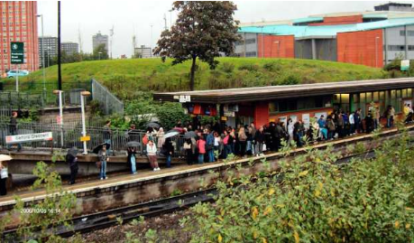

**Exhibit 3 – Salford Crescent Station: Existing Site plan**

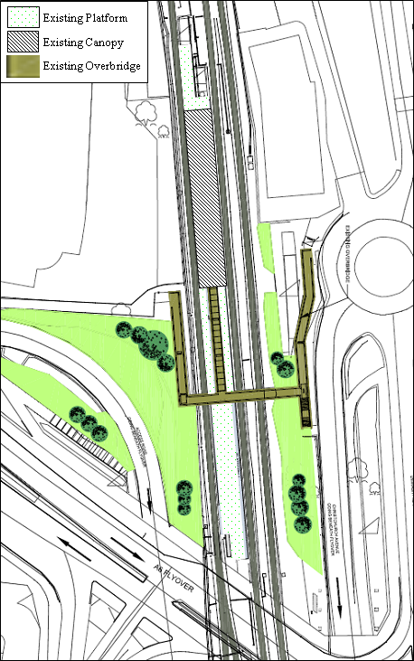

**Exhibit 4 –Plan to Lengthen the Island Platforms**



**Exhibit 5 – Proposed Site plan: De-cluttering plus moving access to the southern end**

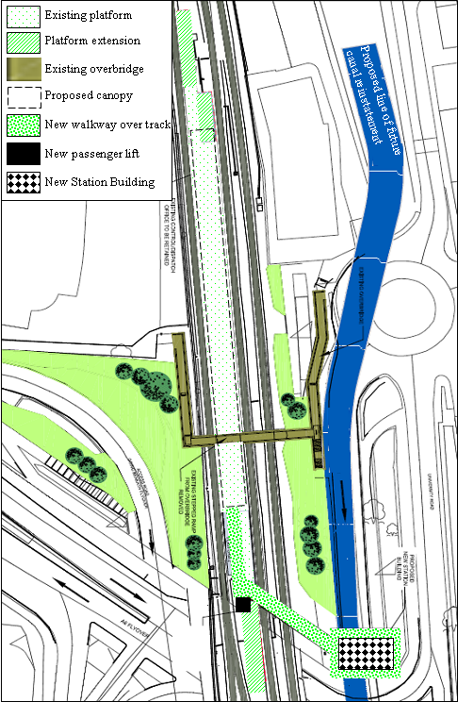

**Exhibit 6- Proposed New Building for Salford Crescent Railway station (Network Rail)**

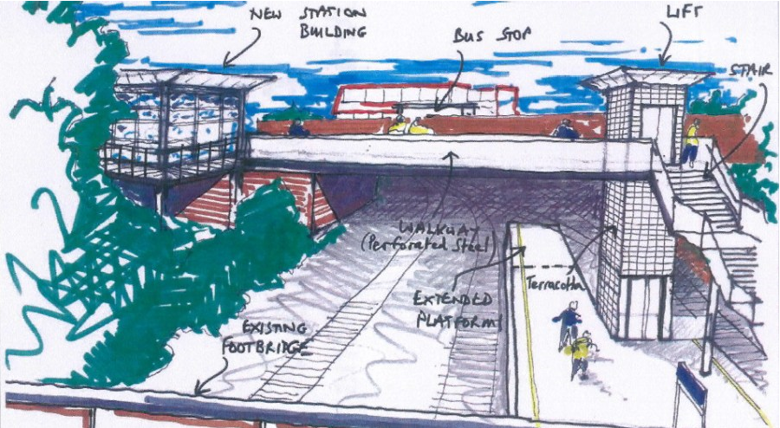

**Exhibit 7 – Proposal to locate ticket office on the west side of the footbridge**

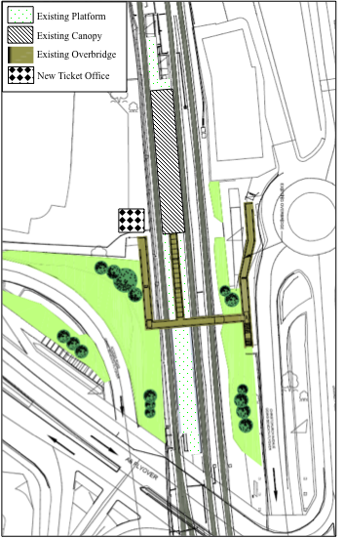

1. NR Enhancement division is responsible for enhancing and enlarging the rail network to deliver new infrastructure and functionality needed for capacity and capability improvements.
2. National rail stations are categorised in six bands, broadly corresponding to their level of use. Major termini are found in category A, whilst unstaffed halts are found in category F. The Rail Passenger Council (now Passenger Focus) states that Category C stations provide important regional connections and have capacity and facilities to serve large numbers of passengers.
3. The HLOS state the government aims for the rail industry in terms of reliability, capacity, and safety.
4. The aspiration to extend Calder Valley services to a new platform linked to the current station would open direct journey opportunities from the Salford area and aid economic development in line with the Salford City Council business case.
5. This and the following estimates are 2010 prices.
6. A switch is a mechanical device to enable trains to be guided from one track to another at a junction; a crossing enables two rails to cross each other without derailing the trains running over them.
7. A possession is a contractual arrangement where train operations on a section of railway are suspended for a defined period of time, normally to allow work to be carried out on the network.
8. NR operates under a public mandate to attend to life-cycle costs when assessing the viability of new schemes, and thus to factor in both capital expenditure (CAPEX) and operational costs (OPEX)